**BX3083: STRATEGIC MARKETING**

ASSESSMENT TASK 3 COLLEGE OF BUSINESS, LAW AND GOVERNANCE



**GROUP TASK COVER SHEET**

|  |  |  |  |  |  |  |  |  |  |
| --- | --- | --- | --- | --- | --- | --- | --- | --- | --- |
| *Students*  *Please sign, date and attach cover sheet to front of assessment task for all hard copy submissions* | | | | | | | | | |
| **SUBJECT CODE** | BX3083 | | | | | | | | |
| **STUDENT FAMILY NAME** | **Student Given Name** | **JCU Student Number** | | | | | | | |
| Tran | Le Binh | 1 | 3 | 4 | 7 | 6 | 1 | 1 | 2 |
| Liu | Yu Wei | 1 | 3 | 4 | 7 | 1 | 5 | 4 | 5 |
| Kim | Tae Wan | 1 | 3 | 4 | 2 | 3 | 4 | 1 | 8 |
| **ASSESSMENT TITLE** | Strategic marketing plan | | | | | | | | |
| **DUE DATE** | 8/1/2019 | | | | | | | | |
| **LECTURER NAME** | Val Philip Ortega | | | | | | | | |
| **TUTOR NAME** | Val Philip Ortega | | | | | | | | |
| **Student Declaration**   1. This assignment is our original work and no part has been copied/ reproduced from any other person’s work or from any other source, except where acknowledgement has been made (see *Learning, Teaching and Assessment Policy 5.1*). 2. This work has not been submitted for any other course/subject (see *Learning, Teaching and Assessment Policy 5.9*). 3. This assignment has not been written for us. 4. We hold a copy of this assignment and can produce a copy if requested. 5. This work may be used for the purposes of moderation and identifying plagiarism. 6. We give permission for a copy of this marked assignment to be retained by the College for benchmarking and course review and accreditation purposes.   [Learning, Teaching and Assessment Policy](http://www.jcu.edu.au/policy/allitoz/JCU_076643.html) 5.1. A student who submits work containing plagiarised material for assessment will be subject to the provisions of the [Student Academic Misconduct Requirements.](http://www.jcu.edu.au/policy/allitoz/JCUDEV_005375.html)  **Note definition of plagiarism and self plagiarism in Learning, Teaching and Assessment Policy:**  **Plagiarism:** reproduction without acknowledgement of another person’s words, work or expressed thoughts from any source. The definition of words, works and thoughts includes such representations as diagrams, drawings, sketches, pictures, objects, text, lecture hand-outs, artistic works and other such expressions of ideas, but hereafter the term ‘work’ is used to embrace all of these. Plagiarism comprises not only direct copying of aspects of another person’s work but also the reproduction, even if slightly rewritten or adapted, of someone else’s ideas. In both cases, someone else’s work is presented as the student’s own. Under the Australian *Copyright Act 1968* a copyright owner can take legal action in the courts against a party who has infringed their copyright.  **Self Plagiarism:** the use of one’s own previously assessed material being resubmitted without acknowledgement or citing of the original. | | | | | | | | | |
| **Student signature(s)**  Tran Le Binh Submission date 8/1/2019  Kim Tae Wan Submission date 8/1/2019  Liu Yuwei Submission date 8/1/2019 | | | | | | | | | |

**Heritage Hostel:**

**Three-Year Marketing Plan**

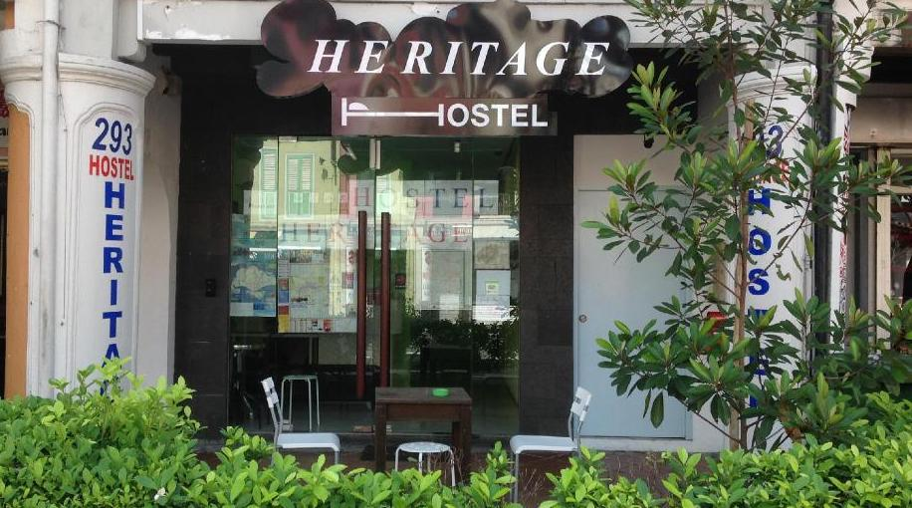

**Prepared For:** Dr Val Philip Ortega

**Prepared by:**

Liu Yuwei: 13471545

Tran Le Binh: 13476112

Kim Tae Wan: 13423418

08/01/2019

**Table of Content**

**1. Introduction 5**

**2. Company/ Organization and Micro-Environment: 5**

**2.1. Company description 5**

**2.2. Company vision and mission statement 5**

**2.3. Current performance, marketing strategy, resources and suppliers 6**

**3. Product and Market Analysis: 7**

**3.1. Product analysis 7**

**3.2. Product life cycle 8**

**3.3. Product portfolio analysis 9**

**4. Target Market and Customer Analysis: 10**

**5. Competitive Analysis: 11**

**5.1. Competitors analysis 11**

**5.2. Competitors revenue 12**

**5.3. Position 12**

**6. Environmental Analysis: 13**

**6.1. Political 13**

**6.2. Economic 14**

**6.3. Social 14**

**6.4. Technology 15**

**6.5. Legal 15**

**6.6. Environmental 15**

**6.7. Overall 16**

**7. SWOT Analysis: 16**

**7.1. Strength 17**

**7.2. Weakness 17**

**7.3. Opportunity 18**

**7.4. Threat 18**

**8. Marketing Objectives: 18**

**8.1. Qualitative: 18**

**8.2. Quantitative: 18**

**9. Competitive Strategy: 20**

**10. Marketing Strategy 21**

**10.1. Product/service strategy: 21**

**10.2. Price strategy: 21**

**10.3. Place (distribution/supply chain) strategy: 22**

**10.4. Promotion (integrated marketing communication) strategy: 23**

**10.5. People (customers and employees) strategy: 24**

**10.6. Physical evidence strategy: 25**

**11. Implementation and Control (Budget and Profit and Loss Account): 25**

**11.1. What to measure? 25**

**11.2. How to measure? 25**

**11.3. When to measure? 26**

**12. Conclusion 26**

**Table of Figure**

**Figure 1: Heritage Hostel’s Product Layer 8**

**Figure 2: Product Lifecycle of Heritage Hostel 10**

**Figure 3: Product Portfolio Matrix of Heritage Hostel 11**

**Figure 4: Target market segmentation 12**

**Figure 5: Heritage Hostel’s competitors 12**

**Figure 6: Competitors Revenue 13**

**Figure 7: Location & Price 13**

**Figure 8: Facilities & Price 14**

**Figure 9: PESTLE Matrix 17**

**Figure 10: Quantitative objectives 19**

**Appendix**

**1.** **Appendix 1: The projected revenue in 3 years** 33

**2.** **Appendix 2: Market share** 33

**3.** **Appendix 3: Profit** 34

**4.** **Appendix 4: Profit and Loss Account** 34

**5.** **Appendix 5: Budget** 34

**Executive summary**

Heritage Hostel’s qualitative objectives is to become the second Airbnb in the market and the member of strategic partnership of HostelWorld. The quantitative purpose is to raise up the revenue by 7 per cent in each year from $261,000 in 2018 to $320,000 in 2021 in three-year plan.

Moreover, the market share is expected to reach 0.10 per cent at the end of 2021 from 0.09% in 2018 to 0.19% in 2021. The profits will also increase by $30,000 from $45,000 in 2018 to $75,000 in 2021.

According to the analysis, Heritage Hostel will adopt the **Focus strategy/Niche strategy** to meet the need of the customers with limited budget rather than meet various kind of customers. The strategies will be applied through the marketing mix strategies (7Ps), which is Product, Price, Place, People, Process, Physical Evidence and Promotion.

There are more than 56 licensed hostels in Singapore with 4 noticeable competitors where the comparison provided including 5 Foot Way Inn, Wink Capsule Hotel, Adler Hostel and Bunc Hostel. The positioning of business will be based on Location & Price, Facilities & Price.

The business core product is Accommodation service and the augmented product is Tickets and Johor Bahru tour. According to the product portfolio, Accommodation is in the cash cow position in product portfolio matrix of Heritage Hostel which generates the highest income, Tickets as the star and little bit of cash cow and Dog for Johor Bahru tour. According to the product life cycle, the business places in the beginning of maturity stage.

The Heritage Hostel’s SWOT analysis will be analyzed through the PESTLE information. Therefore, it indicates the target market.

Lastly, the Budget, Profit and Loss Account will be provided to implement to monitor the marketing plan through the quarter monitor to observe the characteristics of the visitors in different seasons of Korea.

# Introduction

Heritage hostel is an accommodation business located in Chinatown of Singapore where the service offers mainly for tourists, especially for Korean people since 2013. In advance, the business mainly targets Korean tourists with 4 different kinds of rooms and various services such as Accommodation, Ticket and Johor Bahru tour. The marketing plan will outline the business position, target customers, the differentiation between competitors, product and service analysis, micro-environment, SWOT analysis, competitive strategy, marketing strategy and the implementation and control. The aim of marketing plan will develop the permanent strategic marketing plan in 3 years.

# Company/ Organization and Micro-Environment:

## Company description

Heritage Hostel is an independent hostel business which mainly focuses on for Korean tourists. The hostel locates in the vicinity of Chinatown area. It established in 2013 and has provided accommodation services as well as tickets in the Singapore’s tourism industry with the affordable price in the market (Heritage hostel, 2017).

The hostel provides 3 main services to guest regarding the hostel business, the tickets at famous destination tourism like Flower Dome, Cloud Forest, Night Safari and the Johor Bahru tour in Malaysia.

## Company vision and mission statement

The main target customer is Korean tourists, which aims to attract the Korean people to visit Singapore. According to Singapore Tourism Board (STB), the number of Korean tourists reached about 42,484 in 2017, which increasing by 11.46 percent from 2016 and 2017 (STB, 2018).

*2.2.1. The vision:*

To become the pioneer of attracting Korean tourists in the Singapore’s hostel industry.

*2.2.2. The mission*

To offer the quality accommodations in the shopping, restaurants, culture zone of Singapore for business and leisure travelers (Agoda, 2018).

## Current performance, marketing strategy, resources and suppliers

*2.3.1. Performance*

Heritage Hostel’s was built up in 2013 and the sales revenue was SGD$261,000 in 2018. Hence, the accumulated revenue is SGD$1,305,000 from 2013 to 2018.

*2.3.2. Marketing strategy*

It is no denied that there are some weaknesses in conducting marketing strategy.

* Firstly,
* There is no update information or more posts related to business performance as well as the latest destination in Singapore on social media like Facebook or Instagram.
* The website and social media is in Korean language, which becomes the hindrance to attract other visitors from other countries.
* Secondly, the target customer is Korean tourists, which is also considered as the double-edged sword in running the business.

Hence, to increase the sales revenue, the owner of Heritage Hostel depends on the Online Travel Agency (OTA) such as Agoda, Traveloka, Hotelscombined, Tripadvisor.

*2.3.4 Resources*

* There are about 3 staffs working in the hostel.
* The staff education is the major concern from the owner perspective. The education level ranges from high school graduates above
* The staffs are Singaporean and PR citizens whose education is above the high school education level.
* Their role is to control the performance of 8 rooms and to monitor the facilities.

*2.3.5. Suppliers*

The owner of Heritage Hostel collaborates with Maxwell Hawker Center in the vicinity of Chinatown to provide the breakfast to the guests.

# Product and Market Analysis:

### Product analysis

|  |  |
| --- | --- |
| **Levels of Product** | **Range** |
| Core | * Provide accommodation service for the tourists with limited budget * Cheaper accommodation with certain level of quality is guaranteed * Variety choice of rooms for different type of visitors |
| Actual | * Offer 9 types of rooms for different purpose * Offer 18 types of discounted tickets for Singapore attractions * Provide Johor Bahru tour for further explorations and experiences |
| Augmented | * People feel convenient and safety * Affordable price * Easy excess to tourist destinations * Easy to get more information on destinations |

Figure 1: Heritage Hostel’s Product Layer

The Heritage Hostel provides the core service is Accommodation and the actual one is Tickets and Johor Barhu tour.

*3.1.1. Accommodation*

There are 8 types of rooms in Heritage Hotel.

* 1st – It is a twin room which is provided for 2 people and divided into room A and room B. The price per night is S$70 dollars.
* 2nd – It is a couple room which is the same price as the twin room.
* 3rd – It is family rooms which can be used for maximum 3 to 4 people with the price between S$70 and S$140 dollars.
* 4th – It is the female dormitory which is divided into two different room ‘Marina’ and ‘Raffles’.
* Marina room can accommodate maximum 6 people with S$29 dollars per person
* Raffles accommodates maximum 8 people at the same price as Marina.
* 5th – It is the mixed dormitory room ‘Orchid’.
* This room is opened for all visitors regardless of gender and
* It accepts the maximum capacity about 10 people maximum with the same price as the female dormitory

*3.1.2. Tickets*

Those tickets are discounted minimum 5 per cent to maximum 15 per cent that the tourists are keen to purchase to save their budgets.

* The ticket for Sentosa Island’s includes Universal Studio, S.E.A. Aquarium, Cove Water Park, Wings OF Time, Luge & Skyride, Merlion Tower, Sentosa Cable Car, MegaZip + Mega Jump.
* The ticket for main Island and main island activity tickets includes River Cruise, Duck Tour, City Tour Bus – FunVee, Night Safari, Singapore Zoo, River Safari, Jurong Bird Park, Garden By The Bay, Sands Skypark

*3.1.3. Johor Bahru tour*

The staff brings the tourist all the way to Johor to visit attractions and experience the culture of Malaysia.

* The price of the tour is S$550 dollars for 3 people and S$600 dollars for 4 people.
* However, according to Heritage Hostel’s staff, there was no sales for the tour item until the present.

### Product life cycle

The Product life cycle is estimated through the information of hostel establishment, staffs, the percentage that each product and service sales, the possessed revenue of $261,000. To be more specific,

* The percentage of accommodation takes approximately 80 per cent of the service sales
* The tickets take 19 per cent of the service sales
* Johor Bahru tour accounts for 0 per cent of the service sales

Therefore, the product life cycle of Heritage Hostel is in the Maturity stage due to its dominating sales in the company. The ticket and Johor Bahru tour does not appear in the lifecycle because it is evaluated as augmented products.

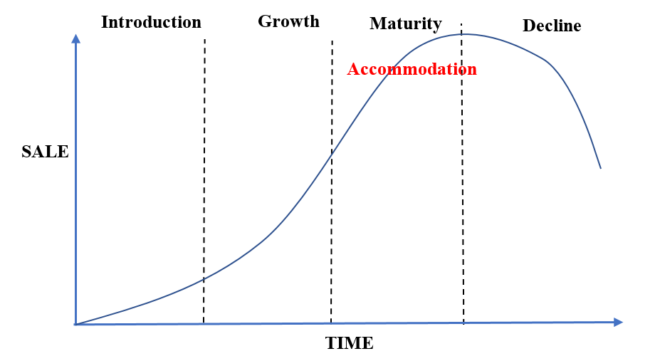

Figure 2: Product Lifecycle of Heritage Hostel

### Product portfolio analysis

The product portfolio matrix of Heritage Hostel is unstably balanced. Accommodation, attraction tickets and Johor Bahru tour is their three major product and service in their business. The evaluation is based on the hostel staff’s analysis on each product.

* Accommodation is evaluated as Cash Cow in the diagram because it is the biggest income generator for the hostel which takes the 80 per cent of whole income of the business.
* The ticket placed in between Star and Cash Cow because it generates the second highest income for the hostel and as mentioned above, which has the limit to generate the profit per day.
* Johor Bahru tour is evaluated as Dog because it generates the profit almost close to zero and its market share is relatively very low to compare with other product and service.

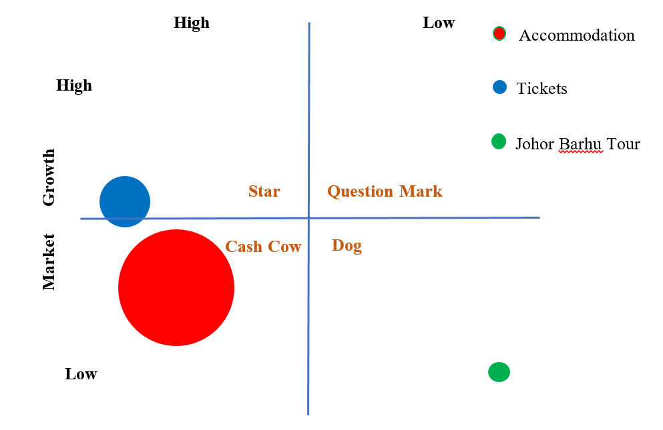

Figure 3: Product Portfolio Matrix of Heritage Hostel

# Target Market and Customer Analysis:

|  |  |
| --- | --- |
| **Segmentation** | **Description** |
| Demographic | * Mainly focuses on Korean tourists and tourists come from other countries around the world * Males and females * Preferred small groups, young couples and short-term business travelers * 20 to 30 years-old * Any marital status and ethnicity * Working professional – students, white-collar workers, retirees * Low to middle income * Any education background |
| Geographic | * 293 South Bridge Road Singapore |
| Psychographic | * Those are allocentrics and enjoying value time with friends and relatives * Enjoys active lifestyle, seek to relax during leisure time * Have interests and hobbies about tourism activities * Have an attitude of taking a break from school or work to rejuvenate themselves. * Those who enjoying the backpacking tourism. |
| Behavioral | * Those are not keen to stay in luxury hotels. * Those are social that willing to stay with strangers |

Figure 4: Target market segmentation

# Competitive Analysis:

#### Competitors analysis

In the hospitality industry, it involves the hostels and the hotel participating in the market. There were about 56 licensed hostels in Singapore in 2013, which means that this number had a significant increase in 2018 (The Straits Time, 2016). There are some noticeable direct competitors in the hostel industry.

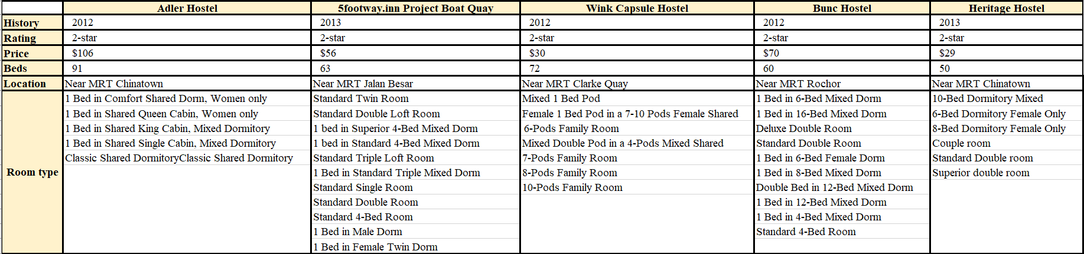

Figure 5: Heritage Hostel’s competitors

#### Competitors revenue

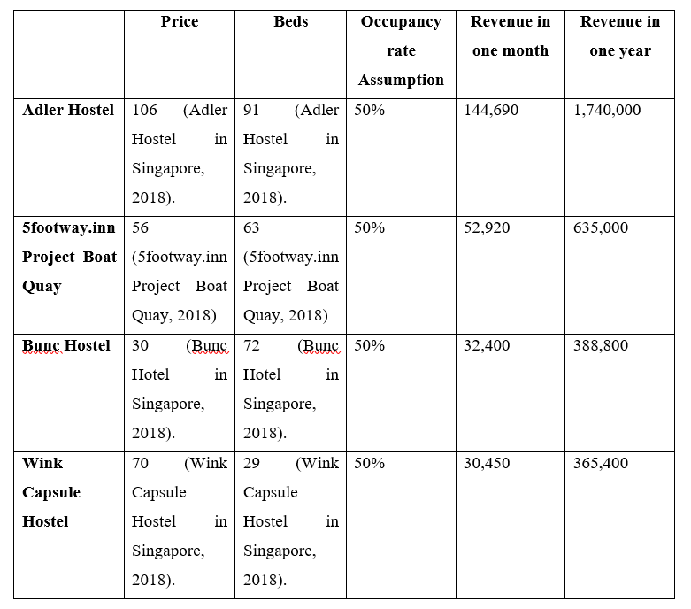

Figure 6: Competitors Revenue

#### Position

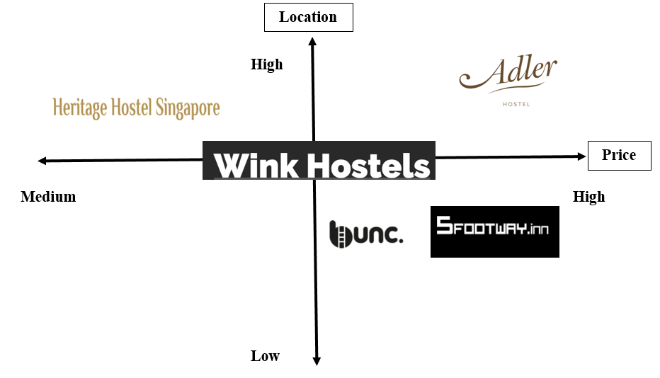

Figure 7: Location & Price

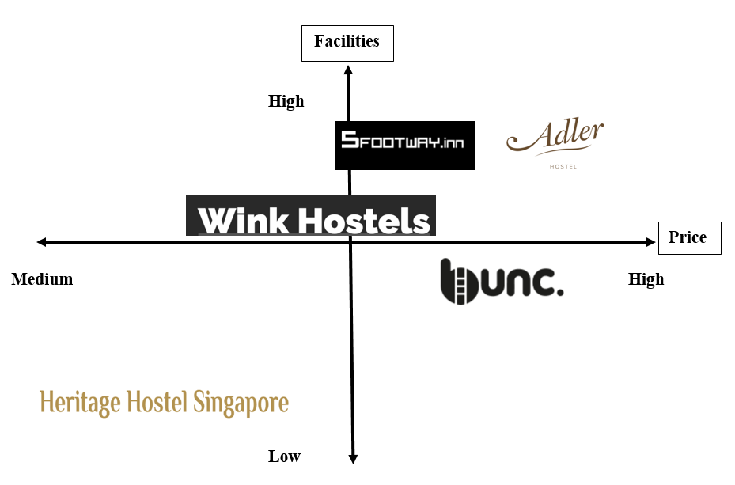

Figure 8: Facilities & Price

# Environmental Analysis:

Political

Overall, the hospitality industry is operated through the stable condition of tourism industry as well as the politics in each nation. Therefore, there are two main factors that affects the Heritage Hostel business.

*6.1.1. The terrorist attack:*

* According to the report of Singapore’s Minister of Defence, after the 9/11 incident in the United States, Singapore faces the highest risk of terrorist attacks with more terrorist incidents, including the May suicide bombings in the Indonesian city of Surabaya and the five-month-long armed conflict with militants linked to Islamic State in Marawi, a city in the Southern part of Philippines (Koutsoukis, 2018).
* In 2014, the terrorist attacks of aviation industry in Malaysia poses a threat for Singapore. MH17 was hit by a Russian-made BUK missile system brought in from Russia and fired from territory in Ukraine held by Moscow-backed rebels (Southeast Asia, 2018).

*6.1.2. The level of safety:*

* The more stable and safe the country is the more amount of hospitality service provide to guests.
* In fact, Singapore has the higher level of competitive advantage. Singapore is one of the World’s safety countries in terms of the lowest level of mugging, crime, road death toll, occurrence of terrorist attacks and wars where the ranking is the fifth (Safe Around, 2017). Secondly, in 2018, Singapore welcomed about 16 million of international visitors (Singapore Tourism Board, 2018).

Economic

The fruitful economy in one country draws a significant attention about foreign investment across the border.

* The Singapore GDP is about S$447,284 million (Department of Statistics Singapore, 2019). Singapore is located at the global and regional transportation hub with a well-established tourism market and good tourism infrastructures.
* Singapore is one of the four financial centers in the world where the rating point is about 769 (Singapore Business Review, 2018).
* For the hospitality industry, the Tourist receipt gained about $12.7 billion including Shopping, Food & Beverage, Accommodation (Singapore Tourism Board, 2018).
* The Average Room Rate gained S$217 billion

Therefore, it represents the positive signal about providing hospitality services in Singapore as well as an increasing demand of hostel employees.

Social

The Singapore Tourism Board (STB) is among the best funded and most proactive in the regions (Savills, 2017).

* Singapore’s passport ranks the third in the world where the local people are able to travel about 165 countries all over the world (Passport Index, 2019).
* From the governments support in domestic tourism and Singapore passport ranking, there are about 48% of Singaporean millennials enjoying travelling.
* The open-mind about travelling from Singaporeans means that there is no anti-social behavior about international tourists, especially for the Korean, which is the main target market of the Heritage Hostel business.

Therefore, the developed economy creates a significant impact for Heritage Hostel. It is no denied that most of hotels in Singapore are expensive and it is limited selection. The hostel business provides further accommodation to tourists.

Technology

* Singapore will become the smart country by using the high technology that address the issue in daily life such as the payment through QR codes for payment, the Driverless cars and the EZ-Link payment system for transportation, the new surveillance Drones for country safety, the Intelligent HDB home systems for household works (The Smart Local, 2018).
* The term of “Smart Hotel Technology” becomes the tendency in the Singapore’s hospitality industry. It involves in taking a selfie for automated check-in at the hotel (The Straits Time, 2017).
* The technology used by the Airbnb allows private individuals to rent rooms or houses directly to tourists. According to the Straits Times, there were an estimated 7,000 Singapore property listings on Airbnb as of November 2016 (Singapore Legal Advice, 2018).

Legal

* Achieving the licensed from the governments makes the Heritage Hostel business run in the future.
* The main legal competitor called Airbnb affects the licensed hostel – Heritage Hostel. Although Singapore has a lot of strict rules regarding the HDB flats and Private properties, there are no laws preventing guests from staying in Airbnb properties in Singapore (Singapore Legal Advice, 2018).

Environmental

The factor that affect the hospitability industry as well as the tourism industry relates to the exploitation of natural resources.

* For the mineral resources, it requires the consumption of fuel to transport the visitors to another country.
* The increasing fuel expense increase results in the increase of air travel in 2019, with fares seen rising 2.6 percent and hotel rates up 3.7 percent (Freed, 2018).

Therefore, the visitors become the pricing sensitive for travelling which results in the decrease demand of booking, the Average Daily Rate and the increase level of the Occupancy rate.

Overall

Overall, the sustainable element of PESTLE is the prerequisite that generates the travel motivation from the tourists and the opportunity to run the business. This creates the plan for conducting marketing strategies in terms of Product, Place, Price and Promotion. The relationship will be provided in **Figure**

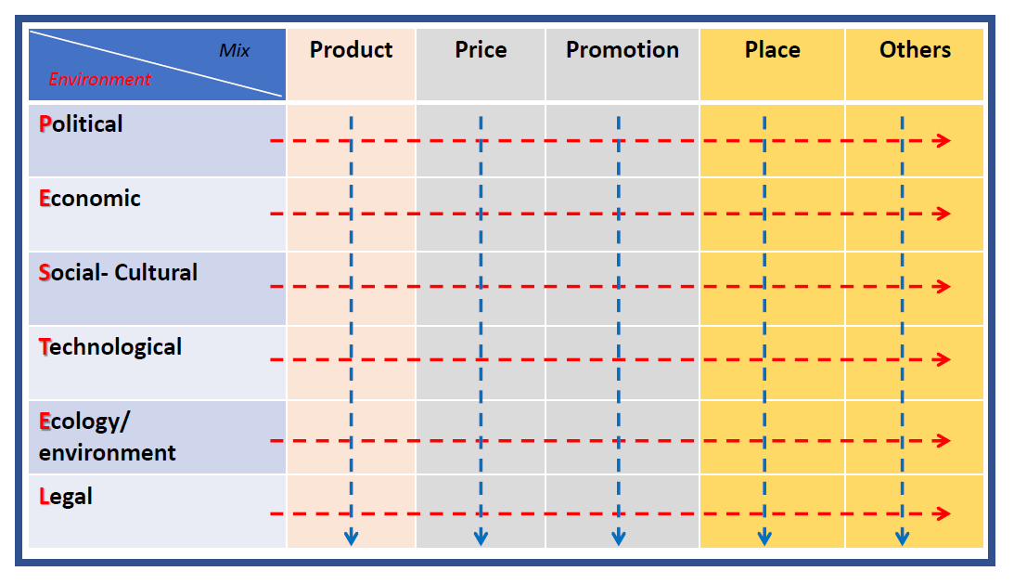

Figure 9: PESTLE Matrix

# SWOT Analysis:

|  |  |
| --- | --- |
| Strengths | * Has prime location * Provides accommodation and tickets with low price * Attracts the backpackers or young tourists with cheaper price motivation * Online reviews to gain the objective evaluation |
| Weaknesses | * Inactive social network * Narrow target market, mainly advertise for Korean people |
| Opportunities | * There are a huge amount of Korean people visiting Singapore * The historical attraction between the United States and North Korea at Sentosa Island |
| Threats | * The participation of huge competitors in hostel industry * The fuel price increases leading to the increased ticket price |

**SWOT analysis**

##### Strength

* Heritage Hostel offers the accommodation service and ticket product with low price which many people can afford.
* The low price of the hostel attracts the visitors like backpackers or young tourists to have a place to sleep with cheaper price which can help to save their budget for more activities.
* The tickets that they sell also give them the chance to experience the attractions of Singapore in discounted price.
* The location of the hostel is Chinatown, which is very close to any downtown or city of Singapore.
* The provision of online review through Facebook page where they were satisfied with the price efficiency. This describes the hostel’s service quality makes the visitors satisfied with the price they have paid.

##### Weakness

* Heritage Hostel’s inactive social network is a weakness.
* Since the hostel is targeting those young travelers or backpackers, the feedback of the previous visitors is very important for next visitors because it is one of the easiest way to make their choice.
* It is true that the pages of the hostel are existing on the social network like Facebook or Instagram, but their activities are stopped since 2017 (Instagram, 2019).
* Regenerating and be active on social network seems very important for them to improve their business performance.
* Furthermore, there is a narrow target market of the hostel. The hostel is mainly advertised their accommodations and tickets for Koreans only so the number of customers that they can distribute their services or products are limited.
* For ticket selling, it can generate the income is relatively higher than the other products or services because it has no limit of selling. If the hostel changes their target market to wider range, the ticket sales will increase.

##### Opportunity

* The number of Korean tourists reached about 42,484 in 2017, which increasing by 11.46 percent from 2016 and 2017 (STB, 2018). Increasing number of tourists is crucial for hospitality industry because it is the main chance for them to attract customers.
* Moreover, since the hostel is mainly targeting Korean tourist, the peace agreement between the United States and North Korea which held in 12th of June 2018, Capella Hotel of Sentosa can be a motivation for the tourists to visit Singapore to experience the historical attraction.

##### Threat

* Business expansion of the competitors is one of the threat to Heritage Hostel. For example, 5 Foot Way Inn expanded their business by having 4 chains near Chinatown with many tourism package such as Tiger Beer Brewery Tour (5 Foot Way Inn, 2019).
* Furthermore, rising fuel price is another threat to Heritage Hostel.
* According to Organization of the Petroleum Exporting Countries (OPEC), the fuel price is keep increasing since 2016 and in 2018, the price of the petrol increased by 36 per cent than the previous year (OPEC, 2019).
* Petrol price is directly connected to air ticket price. So it is very crucial for the tourists for making their decisions to go for a trip or not.

# Marketing Objectives:

###### Qualitative:

The Heritage Hostel aims to become the second Airbnb in the market and the member of strategic partnership of HostelWorld.

###### Quantitative:

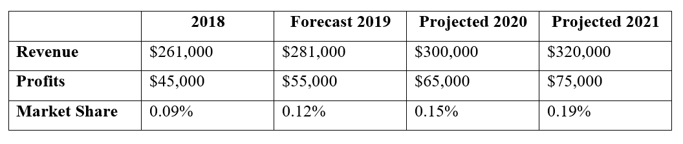

Figure 10: Quantitative objectives

From Figure 10, it is vital to recognized that the percentage of market is small meaning that there is serious fragmented business because

* More than 56 licensed hostels operate in Singapore.
* The market share includes the hostel and the hotel aspect.
* The market share of hotel field is significant larger than the hostel one.

In order to gain the projected revenue of $281,000 and the profits of $55,000, the Heritage Hostel must depend on the **Focus strategy /Niche strategy**. There are some approaches to achieve that anticipated revenue

* The hostel business must deliver the Korean culture message to guests through the decoration, the facilities.
* Offer special deals for Korean people compared with other international visitors.
* Strengthen advertisement in Korea country.
* Create the further business theme related to sustainable strategy.

*8.2.1. Business revenue*

* Heritage Hostel has about 50 single beds. The price costs about SGD $29 and the occupancy rate is 50%. The revenue will calculate as:
* Revenue in one month = Price * 50 * 50% * 30= $29 * 50 * 50% * 30 = $21,750
* Revenue in one year = Revenue in one month * 12 = $21,750 * 12 = $261,000
* The anticipate revenue will be provided in Appendix 1

*8.2.2. Market share*

* The hospitality market share in Singapore is about US $378 million in 2018, which is equal to SGD $292 million (Statista, 2018).
* There are 4 top competitors operating hostel business
* The market share will be calculated as:
* Market share = Own revenue business / Total market share in the industry * 100
* The specific market share of each competitor will be provided in Appendix 2

*8.2.3 Profit:*

* The profit will be calculated as:
* Profit in one month = Daily Sales – Staff Salary – Rental Fee – Utilities
* Profit in one year = Profit in one month * 12
* The detailed profit will be provided in Appendix 3

# Competitive Strategy:

Generally speaking, Singapore's tourism environment shows a positive signal. It is undeniable that Heritage Hostel has a great development opportunity in such environment. The main target customers of Heritage Hostel are those who want to travel with limited budget.

Nowadays, as the requirements of customers become more and more diversified and the competition between hotels becomes increasingly fierce, human resources and funding needs are in insufficient supply.

Moreover, Heritage Hostel promotes to be the dormitory hotel. Travelers with low budget tend to know this kind of hotel and they usually travel alone or travel with many friends. Therefore, the dorm-style hotel is also a symbol of the identity and image of Heritage Hostel to some extent.

We recommend that Heritage Hostel should adopt the **Focus strategy /Niche strategy** to meet the needs of those customers with limited budget rather than meet various kind of customers. Focus strategies concentrate on particular niche markets and, by understanding the dynamics of that market and the unique needs of customers within it, develop uniquely low-cost or well-specified products for the market (Mind Tools Content Team, 2018).

In order to meet the needs of tourists with limited budgets, in addition to maintaining the low price, Heritage Hostel must also

* Improve the quality of service and accommodation.
* Adopt a method different from the competitors and strive to be unique in some aspects that the visitors pay much attention, such as hotel facilities, design or service. In this way, heritage hostel can be distinguished from competitors like Adler Hostel and Wink Capsule Hostel.

Differentiation is providing superior value to customers at a profitable price, is a win-win scenario (Priority Metrics Group, 2016). The differentiation strategy builds competitive advantage by making customers more loyal to the products and more recognized by the price.

* The Heritage Hostel brand can be widely known and at the same time enhance the reputation of the hotel. It can be realized via different ways. Heritage Hostel can pay attention to the service model innovation.
* For a long time, the hotel's rooms have been standardized. Although this service model can meet the customer's standards, it is difficult for customers to be truly satisfied. Therefore, we must innovate ideas, capture the dynamic and implicit needs of customers, and pursue the ultimate service effect. We will provide more detailed instructions on implementing a successful differentiation strategy in the next section of 7P.

# Marketing Strategy

Product/service strategy:

The Heritage Hostel provides the hospitality service to the customers. The service involves the Intangibility, Inseparability, Perishability and Variability.

For the Intangibility,

* The hospitality service relates to provide the service of accommodation for tourists when they visit Singapore.
* It is vital to notice that the Heritage Hostel possesses some tangible products such as luggage storage, laundry machine, WiFi, different type of rooms, heater, staffs, the business facilities stationaries (Traveloka, 2018).
* Therefore, the customers spend their expense to get the accommodation service but they do not have a right to purchase these tangible products.

For the Inseparability,

* There is an intimate relationship between the supply of hostel accommodation service and the consumption of booking rooms from the guests

For the Perishability,

* The business could not run without the empty booking, the country instability, famous and attractive tourist destination
* The more advantages Singapore has, the more tourists arrive and book rooms

For the variability,

* The hostel provides the purchase tickets to Sentosa Island, Flower Dome, Cloud Forest, Night Safari, the Johor Barhu tour

Price strategy:

The key issues in pricing strategy is pricing objectives, supply and demand, the firm’s cost structure, competition and industry structure and the stage of the product lifecycle (Marketing planning and Strategy, 2012).

To make a price strategy for Heritage Hostel, it is necessary to look into the firm’s items which are accommodations, tickets and Johor Barhu tour.

* For accommodation service,
* The price of the service is analyzed relatively the lowest between the competitors.
* Since the number of the Korean tourists are keep increasing, it is a chance for them to increase their price because the demand is rising but the supply is limited.
* This will keep the service in maturity stage to generate higher income for the hostel.
* For the tickets,
* Maintain the price of the tickets because the market share is relatively lower than accommodation service but it is a growing product. Which means, it is better to maintain the price at the present because its demand is lower than the accommodation but unlimited supply.
* Offer the lowest price of the ticket in Singapore so it can be a blue chip for the hostels future.
* For Johor Bahru tour
* Lower down the price of the product for a certain period of time like limited promotion due to the fact that the tour is generating the income which is almost to zero
* If the hostel makes a price promotion for a period of time, the customers might be interested to visit the other place besides Singapore in promotional price.

Place (distribution/supply chain) strategy:

The distribution strategy plays an important role in the hospitality reservation. Heritage Hostel's distribution strategy relies heavily on a variety of information technologies and Internet platforms.

* Firstly:
* The company's official website is an effective service distribution platform because it offers a wide range of features to provide customers with practical room booking assistance.
* At the same time, in addition to the function of hotel reservation, it also provides the function of “Find A Hotel”. This link can help customers search other five star, four star or other kinds of hotel in Singapore.
* Secondly, Singapore’s hotel industry also targets the oversea market.
* Heritage Hostel also cooperates with different large Online Travel Agency such as Agoda, TripAdvisor and Booking so as to attract more and more customers all over the world.
* The application of Internet technologies and platforms is the most effective way for the promotion of the Singapore hotel industry.
* Heritage Hostel chooses Internet platforms to do promotion.
* We take the advantage of social media to promote our products and service. It is quite innovative and beneficial to promote through Internet and social media.
* Singapore hospitality industry aims at oversea customers. If hotels can draw the attention of these customers on the Internet and get to know their requirements, the hotel reservation rate can be increased.

Whether hostels adopt the new social media or traditional booking and ordering website, they need to focus on receiving service and personalized experience. The sales figure is very important but it should not be the only pursuit. In our own sales system, we will add our corporate culture to ensure that the service concept delivered is in line with the company's original intention.

Promotion (integrated marketing communication) strategy:

Currently, the Heritage Hostel depends on Online Travel Agency such as Agoda, Traveloka, Hotelscombined, Tripadvisor, Hostelworld to promote the business brand. The Heritage Hostel offer the lower price to gain more the number of guests.

Due to the limited strategy about promotion, there are some suggestions about promotion vehicles that will enhance the brand awareness to customers.

* Outdoor advertisement

There will be a poster for the Heritage Hostel placed at MRT Chinatown twice a month

* Digital advertisement

There is business page on social media like Facebook, Instagram, Twitter where the content is required to upload every week.

* Printout advertisement
* The business will advertise on Straight Times on Thursday and Friday only once a month. It will be half a page and be printed on the 3rd page of the mains section where most readers will view it.
* The staffs will provide the hostel leaflet near the MRT twice a week
* Public relation
* The special offers to the customers every month on the business websites and Online Travel Agency for the first serve first come basis.

People (customers and employees) strategy:

Heritage Hostel is a 3-star hostel in Singapore. Therefore, apart from product and promotion strategies, service management is of significance.

* The quality of hotel service means whether customers’ needs can be met by the services provided by the hotel and whether the hotel can bring a good experience to the customers.
* However, the quality of service depends to a large extent on the professional knowledge of hotel service personnel and the comprehensive quality of all aspects.

Heritage Hostel is the dorm-style hotel and the lack of practical hotel expertise and enthusiasm has become a major disadvantage. In fact, there are only 3 employers working in the business. Therefore, in order to solve this problem,

* We need to have professional service training and benefits for employees.
* For the different working hours of the front desk staff, we provide separate special trainings and regular special training to ensure the proficiency and professionalism of each business.
* If time permitting, we can properly simulate various roles and emergencies and improve the ability of employees to adapt to the situation.
* Add some services related to Singapore culture. For example, when customers arrive at the hotel, we can provide local Singaporean special drinks as a welcome drink, which does not only relief the physical fatigue caused by the weather, but also allows guests to experience the local characteristics and specialized hotel service on arriving.
* When guests check out, we can give a postcard as a souvenir so that guests can feel the sincere greetings of the hotel when they leave the hotel.
* Sincerity should be melted into our company’s culture and at the same time be embodied by all employees in the warm-hearted way.
* We should improve the sense of belonging of the employees to the hotel. We have established an employee reward system.
* Through the mutual voting between employees and the approval vote of customers, the person with the highest number of votes can enjoy one more day off in the next month. Also, we have the survey for guest to fill when they check out.
* Finally, through the training of employees, the promotion of corporate culture and the reward system, we can improve the service quality of our hotel and the loyalty of our customers.

Physical evidence strategy:

Physical evidence is important because can judge the service quality through the process of deduction (Essays, 2013),

* For the businesses like Heritage Hostel, it is very important to build a strong marketing strategy to advertise their products and services.
* At this point, physical evidence strategy can boost the advertisement of the hostel.

In physical evidence wise, Heritage Hostel is recommended to become more active on online feedbacks to show the evidence that the hostel is maintaining the quality of the service with cheaper price than the other hostels with good locations.

* Marry, S (2017) also indicated that the hospitality industry can take advantage of reviews.
* Users generated content such as reviews have a major impact on a customer’s purchase decision.

It is also very important to let the current customers to notice the existence of social network pages of the hostel to write a review or ‘like’ the page for information for next customers.

* Moreover, the hostel may provide a discount or souvenirs to the customers who wrote a review on travel advising websites or it online page.
* This strategy will bring the brand loyalty of the customer and increase the possibility to visit the hostel again.

# Implementation and Control (Budget and Profit and Loss Account):

What to measure?

* Qualitative objective: the opportunity to become the second Airbnb in the market and the member of strategic partnership of HostelWorld.
* Quantitative objective: the revenue will be $281,000 in 2019

How to measure?

* In order to gain the projected revenue, based on the Profit and Loss Account, the business knows the revenue, the gross profit, the operating expenses of each quarter.
* In order to gain the qualitative objective, based on the Budget, the business will allocate the finance for operating expenses includes Outdoor Advertisements, Digital Advertisement, Print Out Advertisements, Website Maintenance, Public Relation, Food and Marketing Research

When to measure?

* Through the Budget, Profit and Loss Account, the business will measure by quarterly per year with the head office and staffs.
* Reasons:
* Mainly targeting Korean tourists
* Korea has 4 seasons in 1 year so they will travel based on these 4 seasons

# Conclusion

Heritage Hostel is one of the business participating in Hospitality service in Singapore. In the industry, there are some noticeable competitors like Adler Hostel, Wink Capsule Hostel, 5footway.inn Project Boat Quay and Bunc Hostel, which affects the business revenue, profits. Heritage Hostel’s positions is in the Low price & High location, Medium Facilities & Low Price. The product life cycle is at the beginning of Maturity stage. In order to achieve the qualitative and quantitative objectives, the business must apply the Focus Strategy/Niche strategy in terms of 7P.

**References**

Adler Hostel in Singapore. (2018). Retrieved from

<https://sg.hotels.com/ho476051?_=123&PSRC=AFF01&rffrid=mdp.hcom.sg.363.386.15.000.SEO.000.kwrd%3Dtop%2010%20hotels%3Asingapore%3A5%20best%20cheap%20hostels%20in%20singapore>

Agoda. (2019). *Heritage Hostel in Singapore*. Retrieved from <https://www.agoda.com/heritage-hostel/hotel/singapore-sg.html?checkin=2019-01-07&los=1&adults=1&rooms=1&cid=1744321&tag=296af070-585b-2e08-2b67-cc938b0130ff&searchrequestid=bda8dbfb-9066-455e-a569-09e2dcfcf65b&travellerType=-1&ssri=0>

Bunc Hotel in Singapore. (2018). Retrieved from <https://sg.hotels.com/ho456773?_=123&PSRC=AFF01&rffrid=mdp.hcom.sg.363.386.15.000.SEO.000.kwrd%3Dtop%2010%20hotels%3Asingapore%3A5%20best%20cheap%20hostels%20in%20singapore>

Department of Statistics Singapore. (2019). Retrieved from <https://www.singstat.gov.sg/modules/infographics/economy>

**Essays, UK. (2013). *The Importance of the Physical Evidence Marketing Essay*. Retrieved from** <https://www.ukessays.com/essays/marketing/the-importance-of-the-physical-evidence-marketing-essay.php?vref=1>

Freed, J. (2018). *Global Airfares, Hotel Rates to Rise in 2019: Industry Forecast*. Retrieved

from: <https://www.reuters.com/article/us-global-travel-forecast/global-airfares-hotel-rates-to-rise-in-2019-industry-forecast-idUSKBN1KE0DL>

Heritage Hostel (2017). *Information of Heritage Hostel*. Retrieved from <http://www.heritagehostel.net/main/page.html?pid=55>

Hostelworld. (2018). *Hostels in Singapore - Choose from 67 Singapore Hostels with Hostelworld*. Retrieved from: <https://www.hostelworld.com/findabed.php/ChosenCity.Singapore/ChosenCountry.Singapore?page=3>

Koutsoukis, J. (2018). *Singapore Terrorism Threat at Highest Since 9/11, Minister Says*.

Retrieved From: <https://www.bloomberg.com/news/articles/2018-06-30/terrorism-threat-highest-since-9-11-singapore-minister-warns>

**Mary, S. (2017). The Importance of Hotel Reviews. Retrieved from** <http://blog.frontdeskanywhere.com/importance-of-hotel-reviews-infographic>

OPEC (2019). ***Average Annual OPEC Crude Oil Price from 1960 To 2018.* Retrieved from** <https://www.statista.com/statistics/262858/change-in-opec-crude-oil-prices-since-1960/>

Passport Index. (2019). *Global Passport Power Rank*. Retrieved from <https://www.passportindex.org/byRank.php>

Planerware. (2018). *16 Top-Rated Tourist Attractions in Singapore - The 2018 Guide*. Retrieved from <https://www.planetware.com/tourist-attractions/singapore-sin.htm>

Rosenthal, V. (2018). *Rising Singapore Demand Creates Opportunity for Hotel Development*.

Retrieved from: <https://www.hotelmanagement.net/operate/singapore-s-rising-demand-makes-room-for-development-slowing-hotel-supply>

Safe Around. (2017). *World's Safest Countries Ranked*. Retrieved from <https://safearound.com/danger-rankings/>

Savills. (2017). *Singapore Hotel Market Perspectives by Savills hotels*. Retrieved from:

<http://pdf.savills.asia/asia-pacific-research/asia-pacific-research/singapore-hotel-market-perspectives-savills-hotels.pdf>

Singapore Business Review. (2018). *Here's Why Singapore Can't Beat Hong Kong's Financial Centre Ratings*. Retrieved from <https://sbr.com.sg/financial-services/news/heres-why-singapore-cant-beat-hong-kongs-financial-centre-ratings>

Singapore Legal Advice. (2018). *Is Airbnb Illegal in Singapore?* Retrieved from:

<https://singaporelegaladvice.com/law-articles/is-airbnb-illegal-singapore>

Singapore Tourism Board. (2018). Retrieved from <https://www.stb.gov.sg/statistics-and-market-insights/marketstatistics/visitor%20arrivals%202018.pdf>

Singapore Tourism Board. (2018). Retrieved from <https://www.stb.gov.sg/statistics-and-market-insights>

Singapore Tourism Board (2017). *Visitor Arrivals*. Retrieved from <https://www.stb.gov.sg/statistics-and-market-insights/marketstatistics/visitor%20arrivals%202017.pdf>

Southeast Asia. (2018). *MH17: Missile That Downed Malaysia Airlines Jet in Ukraine Came*

*From Russian Military Unit, Investigators Say*. Retrieved From: <https://www.scmp.com/news/asia/southeast-asia/article/2147630/missile-downed-malaysia-airlines-flight-mh17-came-russian>

Statista. (2018). *Hotels - Singapore*. Retrieved from <https://www.statista.com/outlook/267/124/hotels/singapore>

Tan, A. (2017). *Singapore Tourism Doubled in 10 Years, Supports 164,000 Jobs*. Retrieved

from: <https://www.straitstimes.com/business/economy/singapore-tourism-doubled-in-10-years-supports-164000-jobs>

The Smart Local Singapore. (2018*). 7 High Tech Ways Singapore Is Becoming A Smart Nation Without Us Realising It*. Retrieved from <https://thesmartlocal.com/read/smart-tech-sg>

The Straits Time. (2016). *More hostels sprouting up in Chinatown, Little India*. Retrieved from <https://www.straitstimes.com/singapore/more-hostels-sprouting-up-in-chinatown-little-india>

The Straits Time. (2017). *Take A Selfie for Automated Check-In at Hotel Among Technology to Improve Productivity In The Sector*. Retrieved from <https://www.straitstimes.com/singapore/singapore-tourism-board-to-unveil-technology-road-map-in-2018-to-help-hotels-become>

Traveloka. (2018). *Heritage Hostel, Chinatown, Singapore*. Retrieved from <https://www.traveloka.com/en-sg/hotel/singapore/heritage-hostel-3000010011082>

Wink Capsule Hostel in Singapore. (2018). Retrieved from <https://sg.hotels.com/ho463060?_=123&PSRC=AFF01&rffrid=mdp.hcom.sg.363.386.15.000.SEO.000.kwrd%3Dtop%2010%20hotels%3Asingapore%3A5%20best%20cheap%20hostels%20in%20singapore>

**Appendix**

1. **Appendix 1: The projected revenue in 3 years**

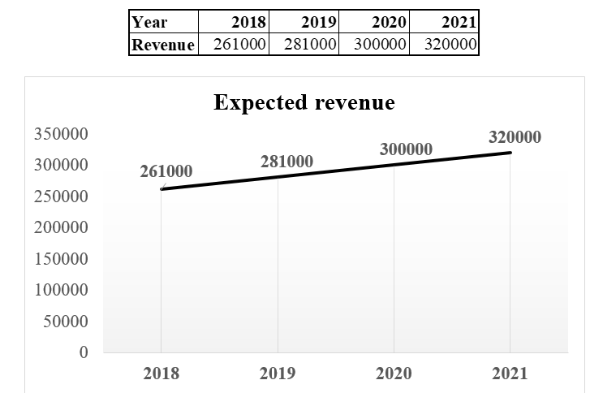

1. **Appendix 2: Market share**

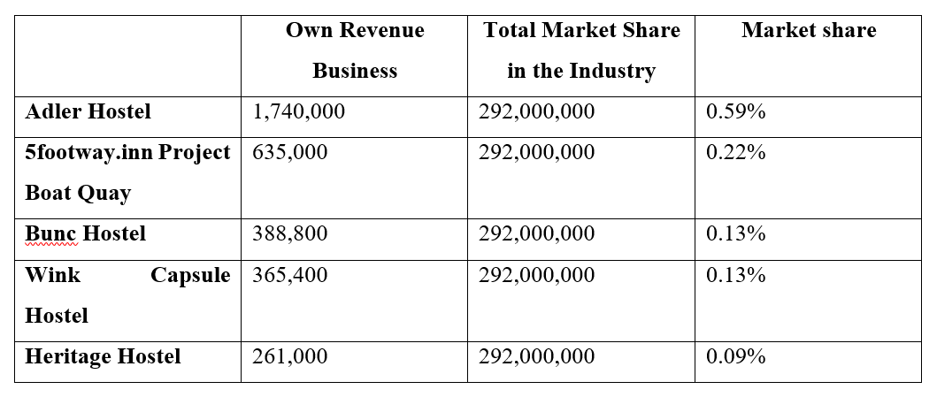

1. **Appendix 3: Profit**

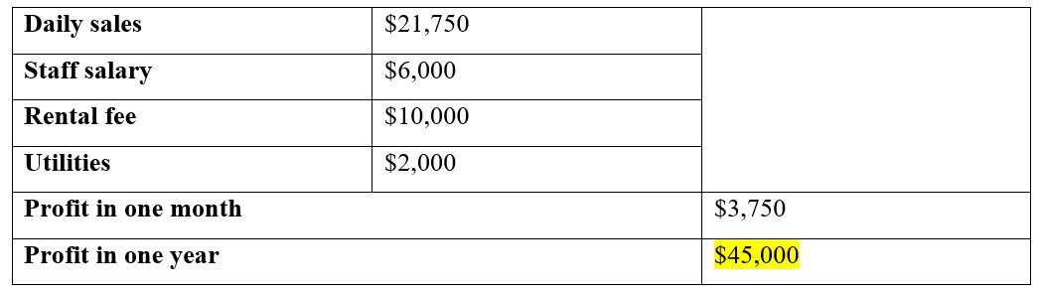

1. **Appendix 4: Profit and Loss Account**

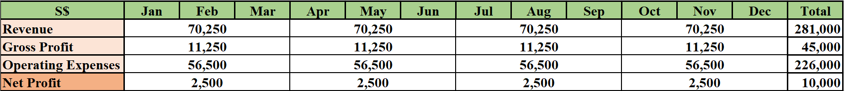

1. **Appendix 5: Budget**

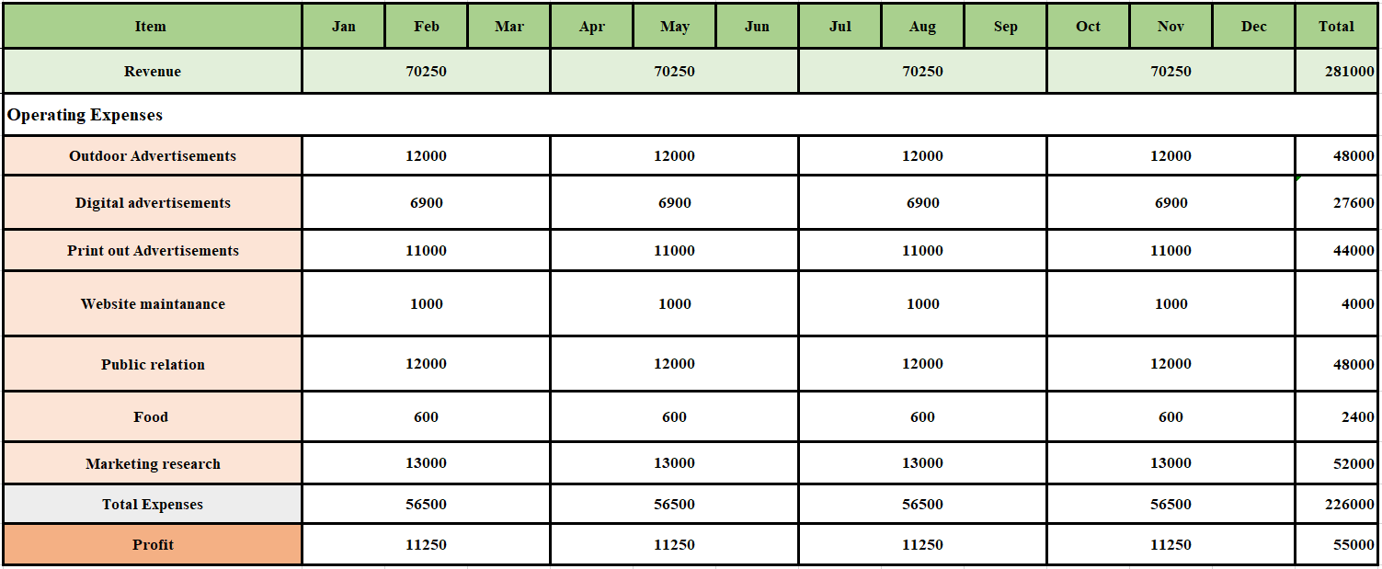

**Success! Your submission appears on this page. The submission confirmation number is 62c23b76-8ac1-4c21-9fb3-4270e10ada3c. Copy and save this number as proof of your submission.**[**View all of your submission receipts in My Grades.**](https://learn.jcu.edu.au/webapps/bb-mygrades-BB5a1f6a34a2e8d/myGrades?course_id=_92939_1&stream_name=mygrades&is_stream=false)